# CS 340 Project Two

## About the Project/Project Title

The goal of the project is to create a dashboard for Grazioso Salvare’s dog adoption program which finds candidates for search-and-rescue training.

## Motivation

Our Client, Grazioso Salvare, wants us to develop an application which can be added to their already existing rescue animal database. Global Rain has been contracted to complete this request in an efficient manner.

## Getting Started

To get started you will need to be able to access the database. As a Global Rain employee working on the project, I was able to use both an admin and regular user credentials to gain access. You will also need our animal_shelter.py module and the script.py script which runs the module.

## Installation

To access the database one would need MongoDB. For the python files, one would need some version of python. The python files were created in python 3.6 and ran in Jupyter Notebooks.

## Usage

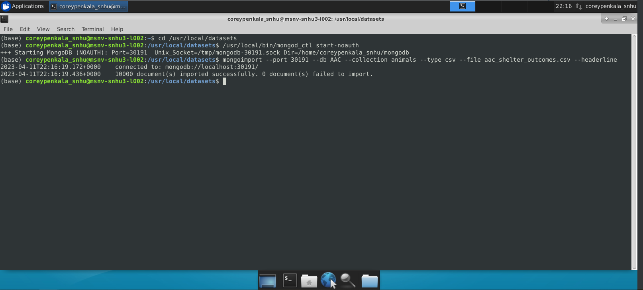

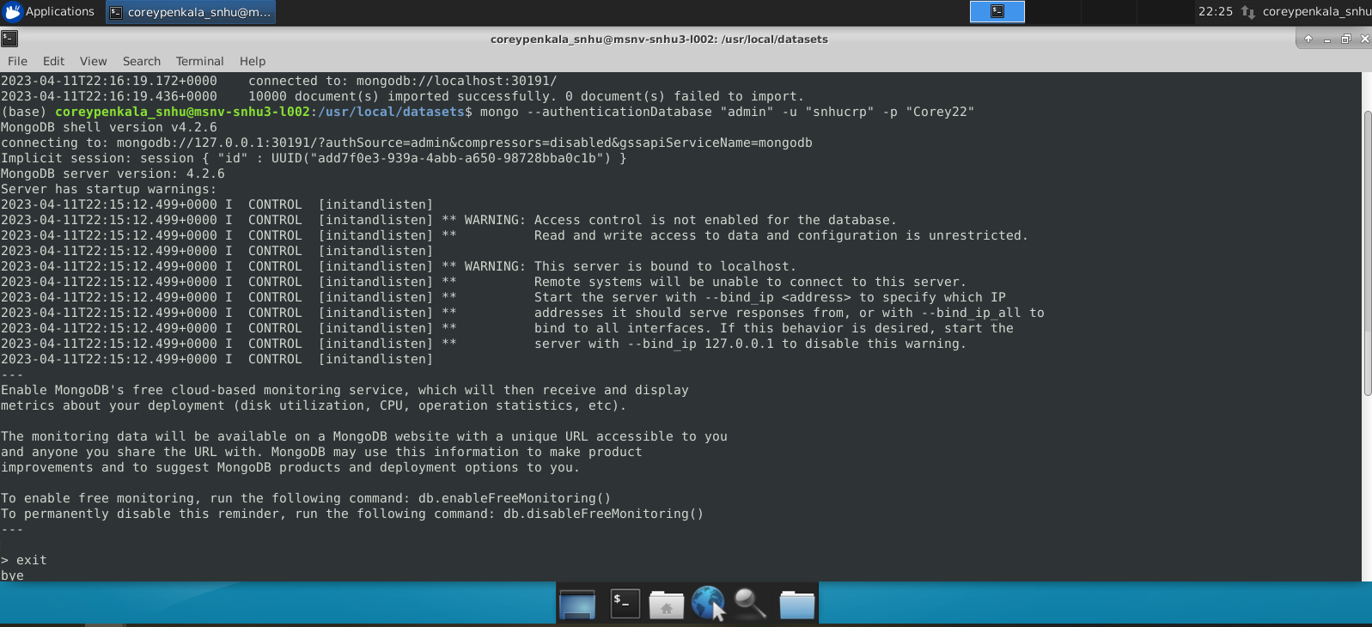

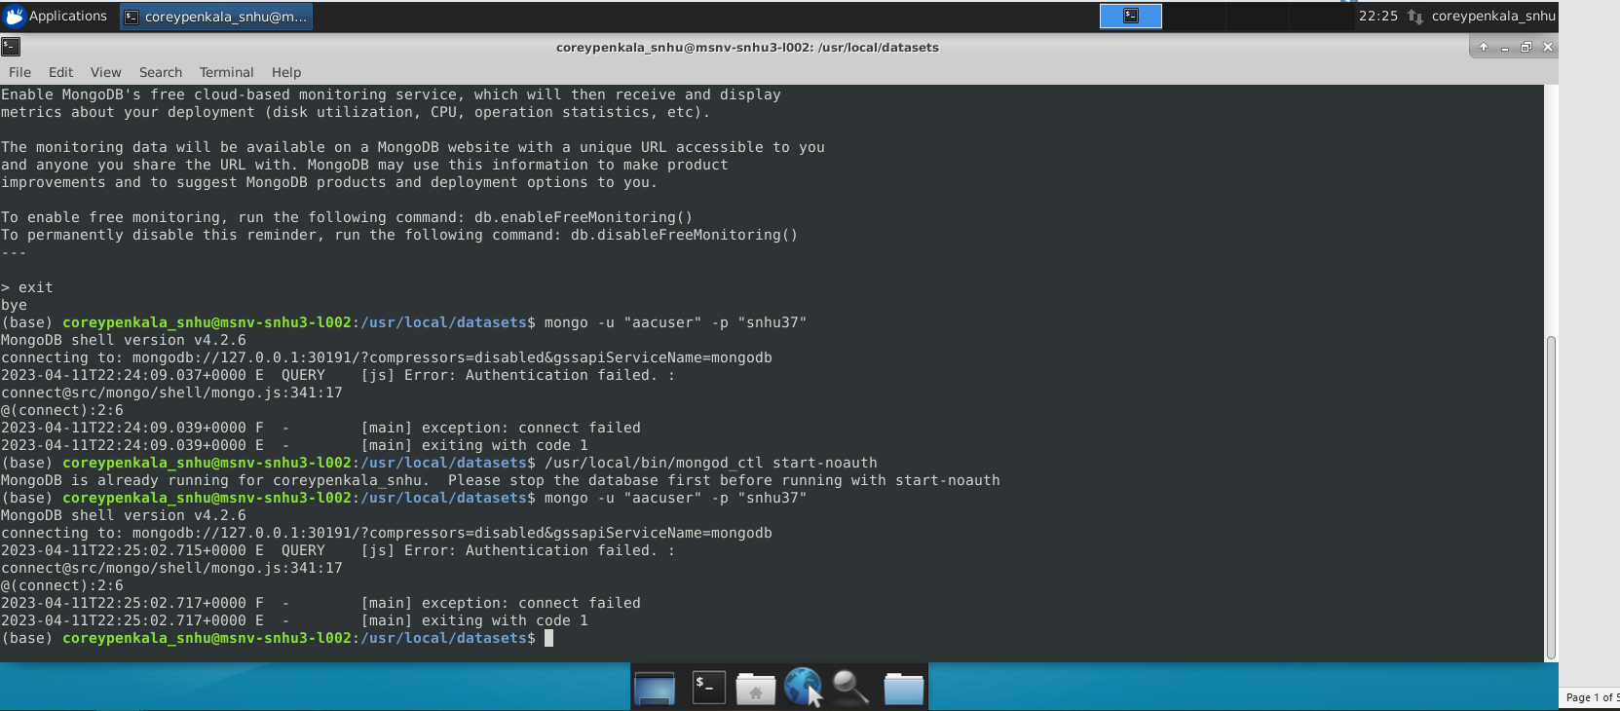

### Code Example

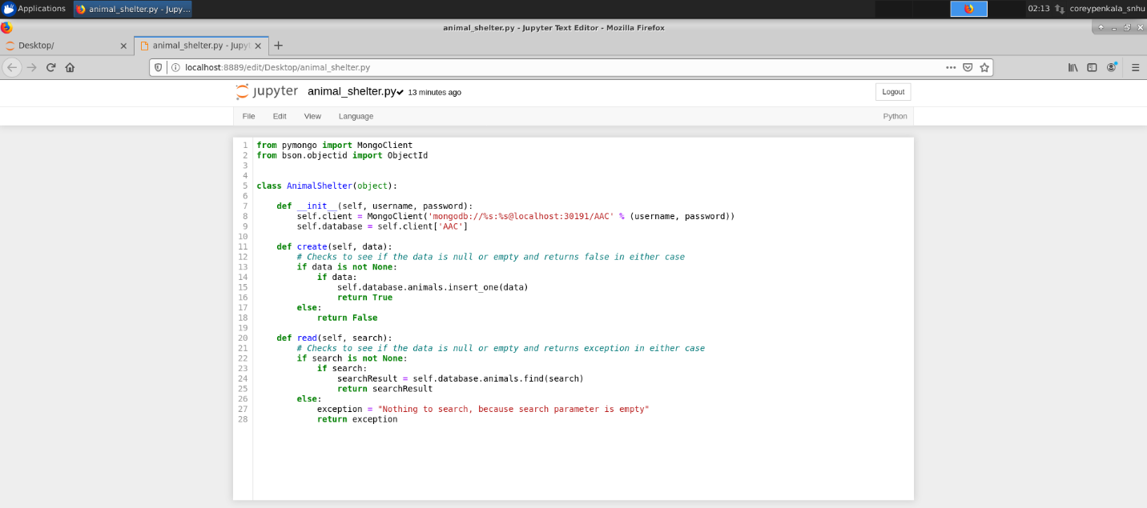

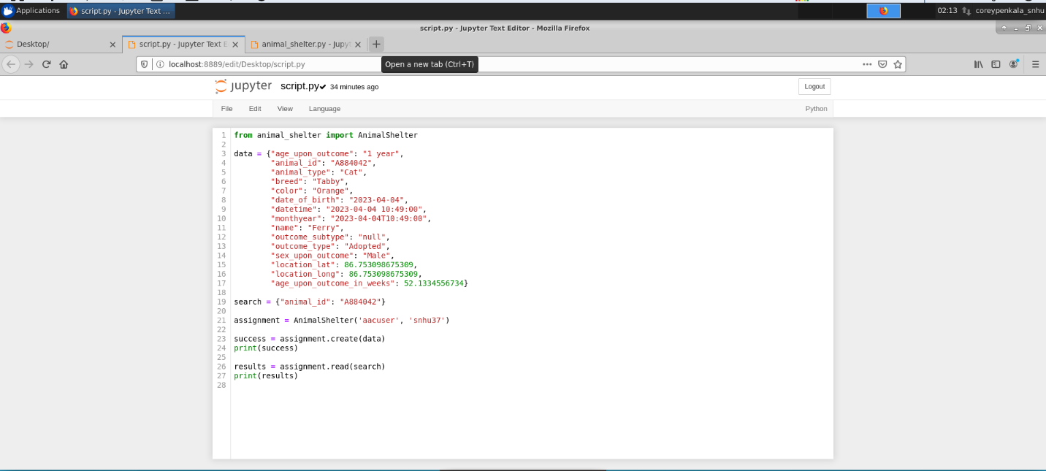

### Tests

Describe and show how to run the tests with code examples.

### Screenshots

Provide screenshots that demonstrate your work.

## Contact

Your name: Corey Penkala